Blue Team: Summary of Operations

**Table of Contents**

* Network Topology
* Description of Targets
* Monitoring the Targets

**Network Topology**

Fill out the information below.

The following machines were identified on the network:

**Name of VM 1: Kali**

* Operating System: Linux
* Purpose: To find the flags and passwords and other penetration test
* IP Address: 192.168.1.90

**Name of VM 2: Target 1**

* Operating System: Target 1
* Purpose: To expose a vulnerable WordPress server
* IP Address: 192.168.1.110

**Name of VM 3 : Capstone**

* Operating System: Terminal
* Purpose: Sends Filebeat and Metricbeat logs to the ELK machine and solely for testing alerts.
* IP Address: 192.168.1.105

**Name of VM 4: ELK**

* Operating System: Terminal
* Purpose: To send the Kibana dashboard and holds the elk docker container.
* IP Address: 192.168.1.100

**Description of Targets**

TODO: Answer the questions below.

The target of this attack was: Target 1 (TODO: 192.168.1.110).

Target 1 is an Apache web server and has SSH enabled, so ports 80 and 22 are possible ports of entry for attackers. As such, the following alerts have been implemented:

**Monitoring the Targets**

Traffic to these services should be carefully monitored. To this end, we have implemented the alerts below:

**Name of Alert 1**

* Extensive HTTP Errors is implemented as follows:
* Metric: When count of http response status code goes above 400.
* Threshold: 400 For The Last 5 Minutes.
* Vulnerability Mitigated: HTTP Response Status Code.
* Reliability: Generates 100 at maximum so I say reliability as LOW.\
* 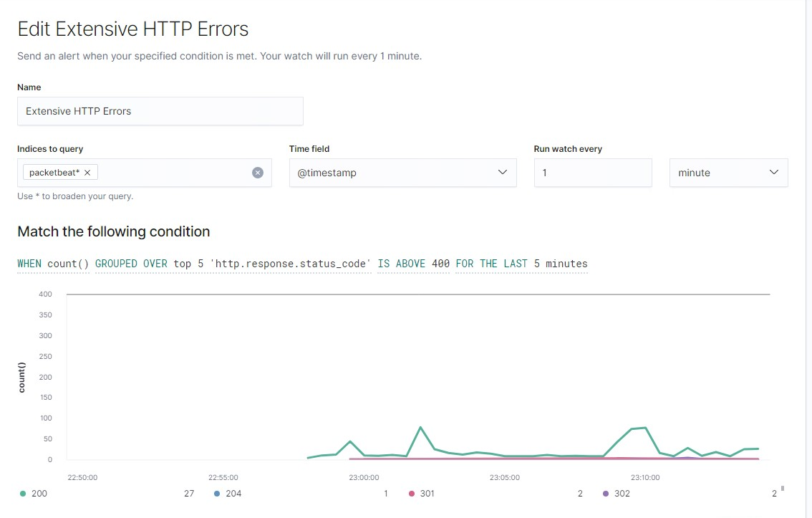Screenshot:

**Name of Alert 2**

* HTTP Request Size Monitor is implemented as follows:
* Metric: when sum of request size goes above 3500.
* Threshold: 3500 Last 1 Minutes.
* Vulnerability Mitigated: Sum of Request Size Exceed the threshold.
* Reliability: as per the report, Five times the result exceeds the threshold set by 1500 values, so I say reliability as MEDIUM
* 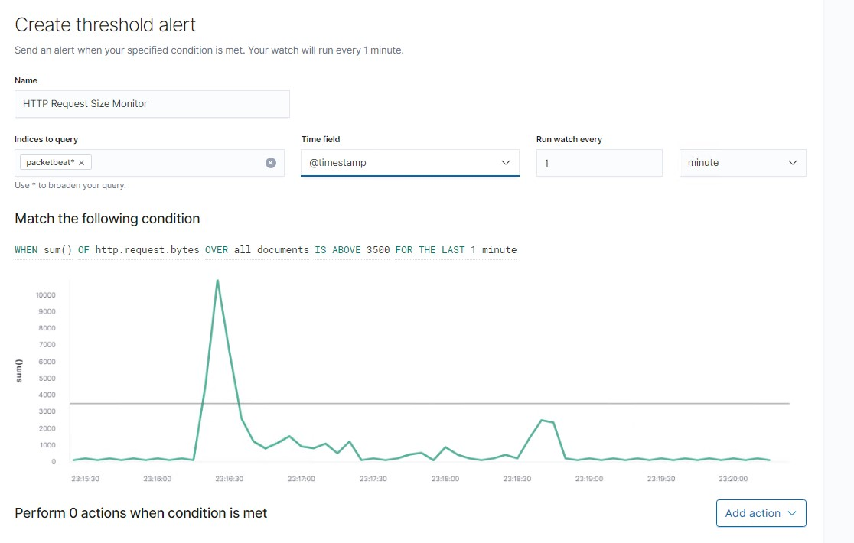Screenshot:

**Name of Alert 3**

* CPU Usage Monitor is implemented as follows:
* Metric: when maximum number of processes running on cpu goes above 0.5.
* Threshold: 0.5
* Vulnerability Mitigated: Maximum System Processes Running on CPU Every Minute.
* Reliability: Reliability is LOW in this alert, because all the cpu usage goes way below 0.5.
* 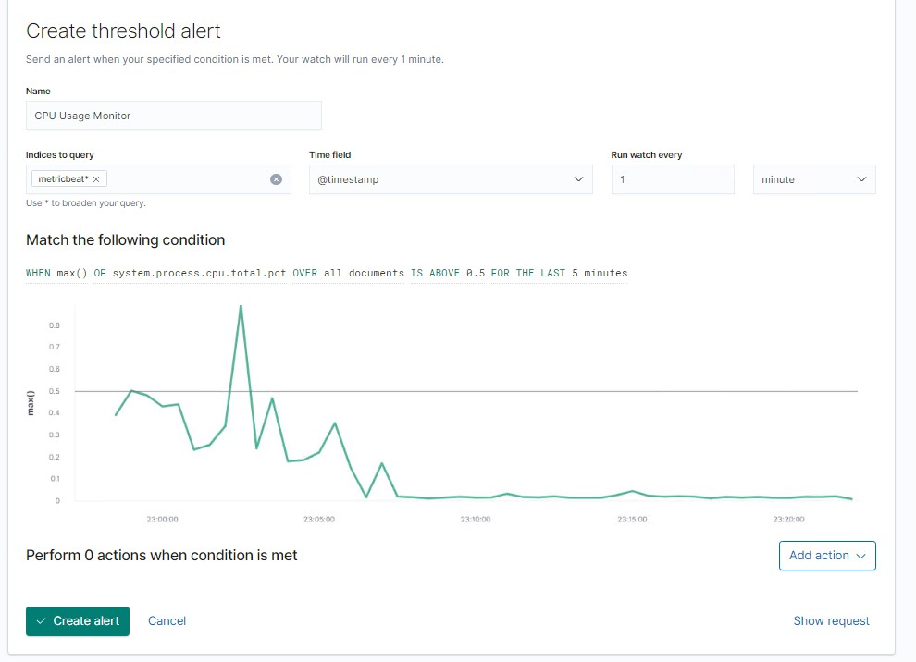Screenshot: